Improving liver ablation treatment for colorectal liver metastases: retrospective assessment of minimum margin to for image guidance and treatment assessment
Brian M. Anderson^{1,2}, Ethan Y. Lin³, Guillaume Cazoulat¹, Sanjay Gupta³, Bruno C. Odisio³, Kristy K. Brock¹
1) Department of Imaging Physics, The University of Texas MD Anderson Cancer Center, Houston, Texas 77030
2) The University of Texas Graduate School of Biomedical Sciences at Houston, Houston, Texas 77225
3) Department of Interventional Radiology, The University of Texas MD Anderson Cancer Center, Houston, Texas 77225

Keywords: Colorectal liver metastases, colorectal cancer, liver ablation therapy, biomechanical model-based deformable image registration

INTRODUCTION
The National Cancer Institute estimates there will be approximately 135,430 new cases of colorectal cancer (CRC) in 2017 and up to 50% of these patients will develop colorectal liver metastases (CLM). The presence of CLM is responsible for approximately two-thirds of the deaths due to CRC¹.
While curative hepatic resection is the treatment of choice for patients presenting with CLM and can lead to a 5-year survival rate of approximately 60%², only 20% of patients are candidates for surgery; image-guided percutaneous thermal ablation (PTA) is widely available for the remaining 80% of patients^{3–6}. PTA has demonstrated 5-year overall survival rates of 24% to 51%^{7–9}. More recently, a prospective randomized phase II trial has demonstrated significantly longer overall survival when incorporating PTA with systemic chemotherapy compared to chemotherapy alone¹⁰.
Several studies have been performed investigating what factors are most relevant in association with local tumor control following liver ablation ^{11–14}. Minimal radiographic ablation margin has been shown to be one of the most relevant ¹⁵. Minimum margins of 5 to 10 mm have been suggested to achieve optimal local control ^{16,17}.
Ensuring sufficient ablation margin can be quite challenging for several reasons. Firstly, tumor visualization is difficult on the intra-procedural non-contrast enhanced CT images obtained for probe guidance. Secondly, streaking artifact from the ablation probe obscures nearby liver tissue, complicating the use of landmarks near the disease for guidance. Thirdly, it is nearly impossible to distinguish between disease and ablated tissue in the post-treatment contrast enhanced scan for hypo-enhancing disease, preventing accurate measurement of delivered margin. Lastly, accurate 3D assessment of ablation margin is difficult as rigid registration is insufficient due to the deformation in the liver throughout the procedure.
Current methods of ablation assessment often rely on a 2D distance measurements to a visible landmark on the post-treatment imaging. This method does nothing to ensure 3D minimum margin.
A workflow has been recently published measuring a 3D margin, the work relies rigid registration which terminates when target registration errors greater than 3 mm are present¹⁸.
We hypothesize that the use of a biomechanical model-based deformable image registration (DIR) retrospectively applied to previously treated patients can identify patients with recurrence based on minimum ablation margin, and that the minimum margin will correlate with actual recurrence. The culmination of which will prove that biomechanical modeling can, and should, be used to ensure sufficient ablation delivery at the time of treatment.

MATERIALS/METHODS

Data
Datum from thirty patients with colorectal liver metastasis treated with local percutaneous ablation therapy at xxx were retrospectively acquired under an IRB approved protocol. Patients were included if: they had a contrast-enhanced pre-treatment image within 45 days of treatment, contrast-enhanced post-treatment image set, and disease site < 3 cm.
These thirty patients were comprised of 14 locally recurring (LR) and 16 non-locally recurring (NLR) patients. Non-locally recurring patients had a minimum follow-up of 76 days, median of 660 days, and mean of 888 days.

Imaging data
Patient imaging data consisted of a diagnostic contrast-enhanced CT images obtained prior to treatment, non-contrast CTs created during the treatment procedure for guidance, contrast-enhanced CT obtained after treatment, used for ablation assessment, and any follow-up imaging. Tri-phase (arterial, portal-venous, washout) CT images obtained with iodinated IV contrast injection acquired prior to the ablation procedure. Non-contrast enhanced CT exams were obtained during the procedure; these exams were often only part of the entire liver, as they were primarily used by the radiologist for needle guidance. Tri-phase CT images were also obtained immediately after the ablation procedure.

All imaging data was uploaded into the radiation therapy treatment planning system (TPS) (RayStation v5.0.2, RaySearch Laboratories, Stockholm, Sweden). The liver was manually segmented on all pre-treatment, intra-procedure guidance, and post-treatment CT images. The venous-phase of the pre-treatment tri-phasic CT was used to delineate the gross tumor volume (GTV) region of interest (ROI), as the contrast between normal tissue and disease was greatest in this phase. A probe ROI was created on the final intra-procedure CT using a simple HU thresholding technique. Tissue that has been ablated does not uptake contrast as readily as non-ablated tissue, facilitating the identification of thermally ablated tissue. The distinction between treated and normal tissue appeared greatest in the venous phase, and this phase was used to create the ablation zone ROI. All segmentations were performed by a graduate student (BMA) and reviewed by a radiology trained physician fellow (EYL). Delineations of GTV and ablation zones on pre-treatment and post-treatment images can be seen for two patients in Figure 1. 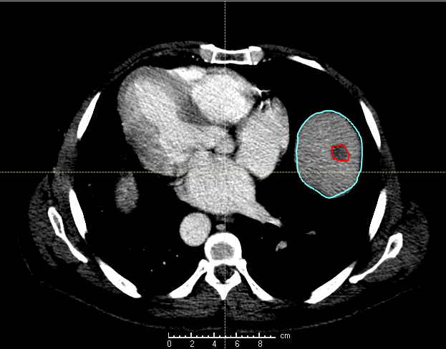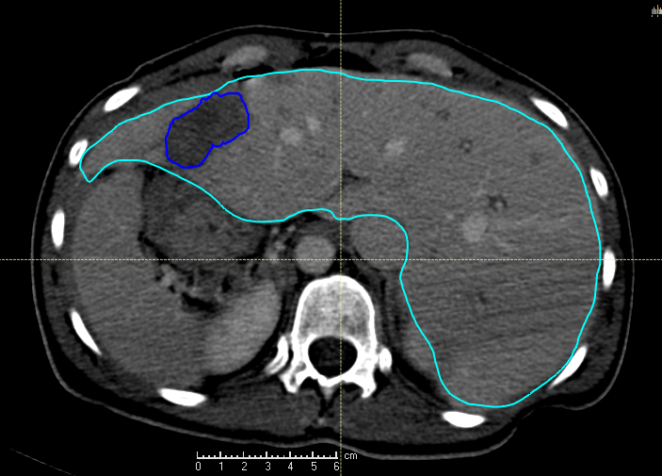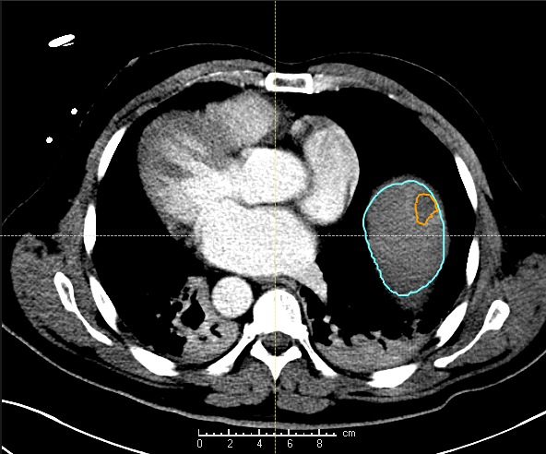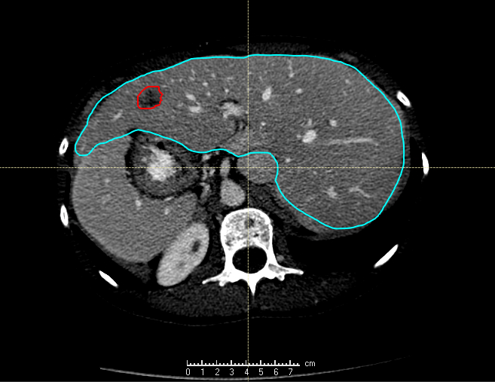
B
B
A
A
C
Figure 1: Two patients are shown, one in the left column and one on the right. (Top Row, A) Contouring of colorectal liver metastasis from diagnostic contrast-enhanced CT (red) and the liver contour (blue). (Bottom Row, B) Contouring of ablation region post-treatment (orange on the left and blue on the right) on the CT obtained immediately following the ablation.

Non-imaging data
Age at procedure, gender, follow-up time, and time to progression were obtained; the gender and age distribution of the patients is given in Table 1. The minimum follow-up time was 76 days, median 660 days, and average 888 days.
Table 1: Data Characteristics. Follow-up is time difference from the procedure to recurrence or the last disease free scan.
 | Recurrence (N=14) | Local Control (N=16)
Gender | 8 Male, 6 Female | 11 Male, 5 Female
Age  Mean (Range) | 60 (33-78) | 57 (36-78)
Follow-up/Recurrence  Mean (Median, Range) | 209 (178, 64-554) | 888 (660, 76-2501)

Biomechanical Modeling
The biomechanical-model based DIR, Morfeus, which has been integrated into the RayStation system was employed for this work^{19,20}. Morfeus has previously been evaluated to have an accuracy on the order of the image voxel size when registering liver images (CT to CT and CT to MR) for image-guided radiation therapy applications^{21,22}.
Morfeus requires the creation of a triangular surface mesh, which defines the relationship between the two image sets. Two parameters govern the creation of this triangular mesh: smoothing radius and triangular-mesh edge length. The smoothing radius is a morphological opening and closing of mesh elements, which helps to remove small deviations in the segmentations of the image sets. Large values will remove true differences in the liver, reducing the accuracy of the registration. The triangular-mesh edge length is the length of the individual triangles which define the mesh. Smaller triangles can require more computation time and overfit on differences in liver delineation, while large triangles can reduce the ability for the mesh to deform accurately. Triangular mesh edge values of 3, 6, 9, and 12 mm (default 6 mm) were investigated and smoothing radii of 1, 3, and 5 mm (default 1 mm) were investigated.
The final selection of these two parameters was determined on a patient-specific basis, where a volumetric prediction metric, the Dice similarity coefficient (DSC)²³, between the generated triangular mesh and the original contours was used to evaluate the mesh.
The triangular mesh is assigned a Young’s Modulus of 1000 Pascals and Poisson’s Ratio of 0.45, values which represent the biomechanical properties of the liver, stiffness and compressibility, respectively, in a linear elastic material model.
The correspondence of the generated triangular mesh determines the boundary conditions for the finite element analysis. The finite element analysis results in a dense and symmetric deformation vector field (DVF), which is resampled to the ROI of the liver contour. The ablation zone ROI was then propagated from the post- to pre-treatment image set using the DVF.

Assessing Ablation
A three-dimensional assessment of minimum ablation margin was created by computing the minimum distance to agreement between the propagated ablation zone and the GTV. Regions where the ablation margin entirely encompassed the GTV were identified as positive margins, and regions where the GTV and ablation region overlap would have a margin of 0 mm.
Since the ablation margin cannot extent outside of the boundary of the liver, the ablation zone is expanded by 10 mm everywhere outside of the liver. This avoids incorrectly identifying small or zero ablation margins due to the nearby boundary of the liver. Figure 2 illustrates two examples of the propagated ablation zone onto the initial imaging is shown in.
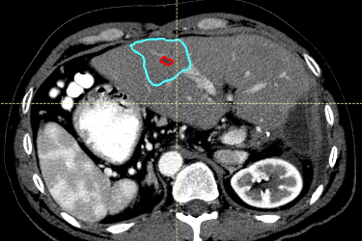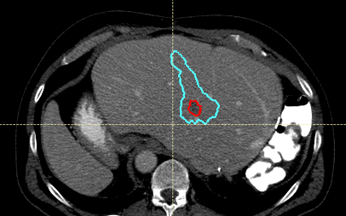
Figure 2: Contours created from ablation region (blue), propagated onto pre-treatment CT via Morfeus deformable registration. The gross tumor volume (GTV) is shown in red.

Assessing Recurrence
The ability to differentiate patients with recurrence is not sufficient if we are unable to identify where the recurrence will likely develop with respect to the delivered ablation zone. In order to assess if the 3D minimum margin corresponds with where tumor progression occurs, we have developed a ray-tracing algorithm that can compensate for the anatomical changes (ablation zone shrinkage of an average ~40% between post-treatment imaging and recurrence) normally seen during patient recovery and recurrence. In order to compensate for the physical changes in the patient anatomy from post-treatment to pre-treatment we perform several steps to best align the post-treatment ablation zone and the recurrence.
First, liver vasculature is automatically segmented using an in-house vesselness algorithm. Next, a sphere of interest of 5 cm centered on the ablation zone in the post-treatment image, and centered on the recurrence in the recurrence image is created. A rigid registration, focused on the vessels present within the 5 cm sphere on both post-treatment and recurrence imaging, is then used to register the two image sets.
To determine if the recurrence aligns with the minimum margin identified on the post-treatment image, a ray-trace is performed. The difference from the centroid of the recurrence image ablation-zone to each point of the recurrence is transformed into spherical coordinates. The phi and theta values of this raytrace are then mapped back onto the post-ablation image, and if they overlap then we can posit that the predictive margin occurred in the same relative direction that the recurrence occurred.
[image of ray trace, recurrence -> post-ablation image]

RESULTS
Deformable registration was completed for all 30 patients, mapping the pre-treatment images with the intra-procedure images and the post-treatment images. The minimum ablation margin was computed as the minimum distance between the tumor and the ablation region, accounting for the close proximity of the boundary of the liver.
Patients without local recurrence (NLR) received an average (min-max, median) 3.19 mm (0.7-6.1, 2.9) of minimum ablation margin around the GTV, while those with local recurrence (LR) received an average of 1.14 mm (0-5.6, 0). Only 3 patients in the LR group had margins greater than 2 mm. A Mann-Whitney U test concluded >99% statistical significance in the difference between the two groups based on 3D minimum distance to agreement. Table 2 shows the minimum distance to agreement between the surface of the GTV and the ablation region for all patients.
Table 2: Minimum distance to agreement between the ablation contour and the tumor contour, stratified between Local Recurrence and Non-Local Recurrence patients
 | min DTA (mm)
Patient # | Local Recurrence | Non-Local Recurrence
1 | 0.0 | 6.0
2 | 5.6 | 6.1
3 | 1.0 | 2.4
4 | 0.0 | 4.8
5 | 0.5 | 2.0
6 | 0.0 | 4.5
7 | 4.7 | 2.8
8 | 0.0 | 3.0
9 | 1.7 | 4.5
10 | 0.0 | 5.2
11 | 0.0 | 2.4
12 | 0.0 | 0.7
13 | 2.4 | 1.4
14 | 0.0 | 2.0
15 | - | 3.0
16 | - | 0.0
Mean | 1.14 | 3.19
Std | 1.81 | 1.78

DISCUSSION
A retrospective study was performed to evaluate the potential impact of using biomechanical model-based DIR to assess the ablation margin following focal therapy for liver metastases. The proposed workflow requires only the contouring of the liver, GTV and ablation region on the pre- and post-treatment imaging. The process is fully automated after receiving segmentations of the GTV, ablation zone, and liver, with run times of approximately 5 minutes. The result returns the ablation margin on the pre-treatment image and an image showing the distribution of ablation zone. This distribution can assist the physician in identifying where further ablation may be desired.
The efficacy of this was shown by correctly separating the retrospectively obtained LR and NLR patients with high statistical significance. Ideally this tool can help improve local control rates in patients, if performed in a timely manner that does not adversely affect the clinical workflow.
The bottleneck of liver segmentation has been largely removed by our recently created deep learning liver segmentation model. In a blinded comparison of 50 patients by three physicians, deep learning segmentations were preferred 60% (30/50) of the time to manual contours, and found to be immediately clinically usable 96% (48/50) of the time[ref].
Our study showed that the differences in minimum ablation margin between the locally recurring and non-locally recurring groups was particularly large (2 mm, nearly 50% of desired minimum margin for microwave therapy) and statistically significant. The program may benefit from smaller time gaps between the initial planning CT and the ablation procedure (< 1 week). Some patients with time gaps as large as 30 days had noticeable differences in liver appearance, which may adversely affect the DIR uncertainties.
The time associated with contouring of the liver is not included in the 5 min program run time. To remove the rate-limiting step of liver segmentation in the creation of the biomechanical model, we have created a deep learning algorithm capable of segmenting the liver and has been extensively validated at our institution. It is capable of segmenting with physician level quality in < 10 seconds, as validated in a blinded comparison among three physicians and 50 patients. The model is currently deployed within the clinic at our institution.
In the focal treatment of patients presenting with CLM there is substantial opportunity for additional image guidance tools to be integrated into the procedure processes to aid in the successful ablation of the tumor. In addition to determining the ablation margins, the algorithms proposed in this research can also be employed to ensure accurate placement of the probe into the tumor, especially in cases where contrast is no longer present in the image of the probe artifact masks the tumor visibility. This would require a CT scan of the entire liver to guide the biomechanical models.

CONCLUSION
Ensuring local control requires adequate ablation of the CLM. The use of biomechanical model-based DIR can assist in identifying if sufficient ablation margin has been delivered to prevent local recurrence. Further investigation is warranted to determine the overall potential clinical impact; however, early results show the potential for clinical benefit without major impact on clinical workflow.

REFERENCES
1. Tomlinson, J. S. et al. Actual 10-year survival after resection of colorectal liver metastases defines cure. J. Clin. Oncol. 25, 4575–80 (2007).
2. Abdalla, E. K. et al. Recurrence and outcomes following hepatic resection, radiofrequency ablation, and combined resection/ablation for colorectal liver metastases. Ann. Surg. 239, 818–25; discussion 825-7 (2004).
3. Liu, L.-X., Zhang, W.-H. & Jiang, H.-C. Current treatment for liver metastases from colorectal cancer. World J. Gastroenterol. 9, 193 (2003).
4. Shady, W. et al. Percutaneous radiofrequency ablation of colorectal cancer liver metastases: Factors affecting outcomes-a 10-year experience at a single center. Radiology 278, 601–611 (2016).
5. Ahrq. Local Hepatic Therapies for Metastases to the Liver From Unresectable Colorectal Cancer Comparative Effectiveness Review Number 93.
6. Weng, M. et al. Radiofrequency Ablation versus Resection for Colorectal Cancer Liver Metastases: A Meta-Analysis. PLoS One 7, e45493 (2012).
7. Gillams, A. R. & Lees, W. R. Five-year survival in 309 patients with colorectal liver metastases treated with radiofrequency ablation. Eur Radiol 19, 1206–1213 (2009).
8. Kim, K. H. et al. Comparative analysis of radiofrequency ablation and surgical resection for colorectal liver metastases. J. Korean Surg. Soc. 81, 25 (2011).
9. Solbiati, L. et al. small liver colorectal Metastases Treated with Percutaneous radiofrequency ablation: Local Response Rate and Long-term Survival with Up to 10-year Follow-up 1. Radiol. n Radiol. 265, (2012).
10. Ruers, T. et al. Local Treatment of Unresectable Colorectal Liver Metastases: Results of a Randomized Phase II Trial. JNCI J. Natl. Cancer Inst. 109, (2017).
11. Berber, E., Pelley, R. & Siperstein, A. E. Predictors of Survival After Radiofrequency Thermal Ablation of Colorectal Cancer Metastases to the Liver: A Prospective Study. J. Clin. Oncol. 23, 1358–1364 (2005).
12. Abitabile, P., Hartl, U., Lange, J. & Maurer, C. A. Radiofrequency ablation permits an effective treatment for colorectal liver metastasis. (2006). doi:10.1016/j.ejso.2006.10.040
13. Hamada, A. et al. Radiofrequency ablation for colorectal liver metastases: prognostic factors in non-surgical candidates. Jpn. J. Radiol. 30, 567–574 (2012).
14. Liang, P. et al. Prognostic Factors for Percutaneous Microwave Coagulation Therapy of Hepatic Metastases. Am. J. Roentgenol. 181, 1319–1325 (2003).
15. Kim, Y. et al. The Minimal Ablative Margin of Radiofrequency Ablation of Hepatocellular Carcinoma (&gt; 2 and &lt; 5 cm) Needed to Prevent Local Tumor Progression: 3D Quantitative Assessment Using CT Image Fusion. Am. J. Roentgenol. 195, 758–765 (2010).
16. Sotirchos, V. S. et al. Colorectal Cancer Liver Metastases: Biopsy of the Ablation Zone and Margins Can Be Used to Predict Oncologic Outcome. Radiology 280, 949–959 (2016).
17. Odisio, B. C. et al. Local tumour progression after percutaneous ablation of colorectal liver metastases according to RAS mutation status. Br. J. Surg. 104, 760–768 (2017).
18. Kaye, E. A. et al. Volumetric 3D assessment of ablation zones after thermal ablation of colorectal liver metastases to improve prediction of local tumor progression. doi:10.1007/s00330-018-5809-0
19. Brock, K. K., Sharpe, M. B., Dawson, L. A., Kim, S. M. & Jaffray, D. A. Accuracy of finite element model-based multi-organ deformable image registration. Med. Phys. 32, 1647–1659 (2005).
20. Velec, M. et al. Validation of biomechanical deformable image registration in the abdomen, thorax, and pelvis in a commercial radiotherapy treatment planning system. Med. Phys. 44, 3407–3417 (2017).
21. Brock, K. K., Dawson, L. A., Sharpe, M. B., Moseley, D. J. & Jaffray, D. A. Feasibility of a novel deformable image registration technique to facilitate classification, targeting, and monitoring of tumor and normal tissue. Int. J. Radiat. Oncol. Biol. Phys. 64, 1245–54 (2006).
22. Voroney, J.-P., Brock, K. K., Eccles, C., Haider, M. & Dawson, L. A. Prospective comparison of computed tomography and magnetic resonance imaging for liver cancer delineation using deformable image registration. Int. J. Radiat. Oncol. 66, 780–791 (2006).
23. Dice, L. R. MEASURES OF THE AMOUNT OF ECOLOGIC ASSOCIATION BETWEEN SPECIES.

